

**Lifelong Learning**

**Learning Beyond The Classroom**

**Submitted by: Ho Bing Hui**

**Matriculation Number: U1721376E**

**Supervisor: Dr Shao Xuguang**

**Examiner: Assoc Prof Tang Xiaohong**

School of Electrical & Electronic Engineering

A final year project report presented to the Nanyang Technological University

in partial fulfilment of the requirements of the degree of

Bachelor of Engineering

2020

Table of Contents

Chapter 1 Introduction 1

1.1 Background 1

1.2 Motivations 1

1.3 Objectives and Scopes 2

1.3.1 Learner 2

1.3.2 Instructor 2

1.3.3 Admin 3

1.4 Project Plan 3

Chapter 2 Current Progress 5

2.1 Research 5

2.2 Application Diagrams 5

2.2.1 Sitemap 5

2.2.2 User Flow Diagram 6

2.3 Low-fidelity Wireframes 7

2.4 CodeBase 7

2.4.1 File Structure 7

2.4.2 Login/Registration 8

2.4.3 Profile Page 9

2.4.4 Course Creation 10

Chapter 3 Future Progress 11

Chapter 4 Conclusion 12

References 13

# Introduction

## Background

The way we live, work and learn are dependent on technologies. And as we know, technologies are always changing and improving. In order to not be left behind, we have to continuously update our knowledge and skills. This make learning a continuous process and no longer fixed to a certain period of our lives.

Online learning, where learning is done over the internet as compared to traditional face to face learning has been on the rise in the recent decade due to the improvement in technology. Many have debated between online and traditional learning; each have their own pros and cons. Traditional learning are effective due to better communication between learners and instructor. Online learning is more efficient as it can be done through the internet.

This web platform will be used to supplement the physical class of lifelong learning courses (traditional learning) with gamification ideas to motivate continuous learning beyond the classroom.

## Motivations

Lifelong learning is a self-initiated education that focus on personal development. We take these courses to gain new skills or to improve our current skills. There are many platforms out there that provides these services. However, most of these courses are usually a one-time thing. Once completed, you get a certificate of completion and that is it. Whether the learners actually grasp the concept, put it to use or refresh these skills in the future solely depend on them. Therefore, I aim to solve these issues through my project which is used as a supplement to physical classes.

## Objectives and Scopes

The project aims to design and develop a web application to supplement physical class of lifelong learning by encouraging and motivating learners to continue learning and improving their personal skills. This is done through the gamification of the platform and also provide a platform where learners can discuss on topics related to the courses they took.

The project scope involves designing and development of a fully function web application that will enable users to do the following.

### Learner

Learners will be the main users of our platform.

1. They will be able to view and register for courses that are provided on the platform.
2. Learner’s board for the individual course will be accessible when learners register for a course.
3. They will also be able to see their statistic and achievement on the platform.

### Instructor

Instructor will be the second main user of our platform. Instructor will have the same access as learners including the rights to create and manage their personal courses.

1. They will be able to view all available courses.
2. They will be able to view ad edit their own courses
3. They will be able to access learner’s board of their own course or their registered courses
4. They will also be able to see their statistic and achievement on the platform.

### Admin

Admin will be managing the data of the platform. Main data that an admin can manage is user and course data. Admin portal will be a separate website and should not be accessible by either the user or instructor.

1. Able to view all data on the platform. Such as list of users, list of courses, list of forum threads.
2. Able to delete any of the above data

## Project Plan

My strategy and plan were to first come up with a list of pages that I will need to include into the web application. From there, I come up with a simple wireframe for the pages so that I have a general idea on how the page will look like.

As design is one of my weaker point, I worked on the wireframe starting from the pages that I planned to work on first. Basically, the design and coding the pages are doing concurrently. Through seeing it on the web will make designing for me easier.

The following diagrams are the timeline for my project. The timeline might be a bit stretch out, but I planned to do more during the winter break so as to have a bigger safety net in case unexpected problem arise.

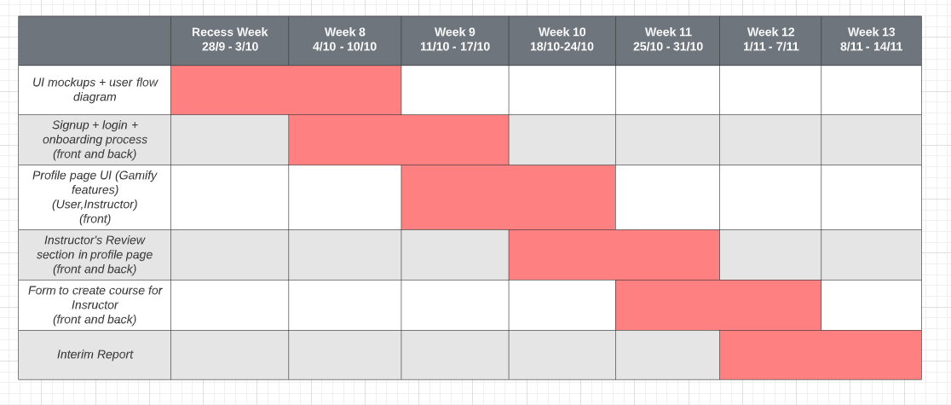

Figure 1.3.1 Gantt Chart for semester 1

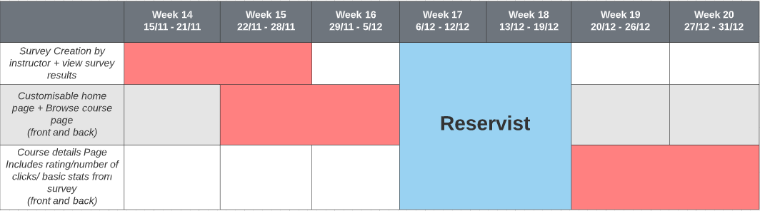

Figure 1.3.2 Gantt Chart for winter break

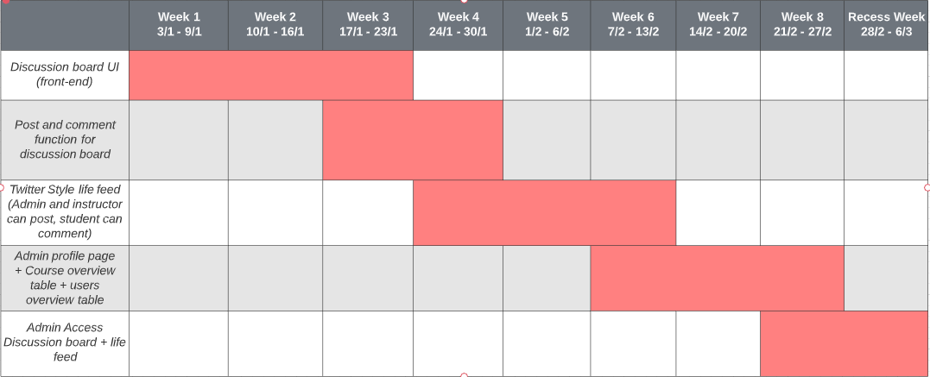

Figure 1.3.3 Gantt Chart for semester 2 (first half)

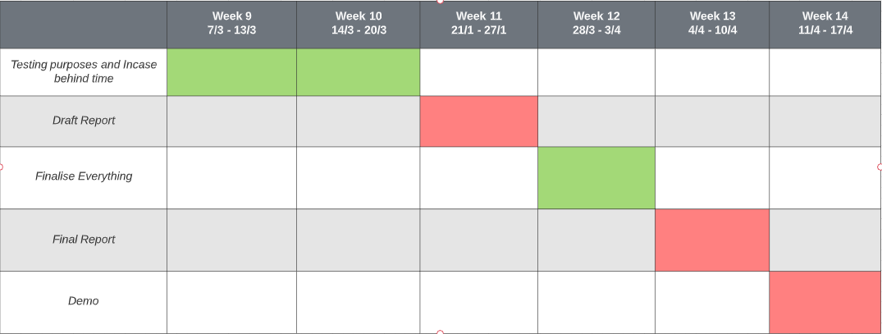

Figure 1.3.4 Gant Chart for semester 2 (second half)



Figure 4.3.5 Legend for Gantt Chart

# Current Progress

I have been putting in consistent effort of at least 2 working days a week to work on my project. I believed I am currently up to date with my planned completion. Below are the progress I have done in this semester.

## Research

Before I start on my project, I did research on the different type of technologies that I can use. There are two main languages for my considerations which are PHP or JavaScript (JS). JS is a client-side scripting language while PHP is a server-side scripting language.[1] PHP is a widely used language in developing web application but in recent years, JS has been gaining popularity and many frameworks that is based on it.[2]

There are also two different types of database, SQL and NoSQL database. SQL databases is a relational database where data are usually store in a tabular manner. NoSQL database are non-relational and distributed where data are usually stored in a document manner.[3]

These are just some of the research I did. There are also different frameworks under PHP or JavaScript that I still need to decide on when I choose my programming language. It is the same for SQL or NoSQL databases. There are many of them in the market.

More in depth information on why I choose certain technologies will be written in the final report.

## Application Diagrams

### Sitemap

I worked on the sitemap for the application to have an overview of the applications. This will help clarify the purpose of my website and also to prevent duplicating similar functions or codes.

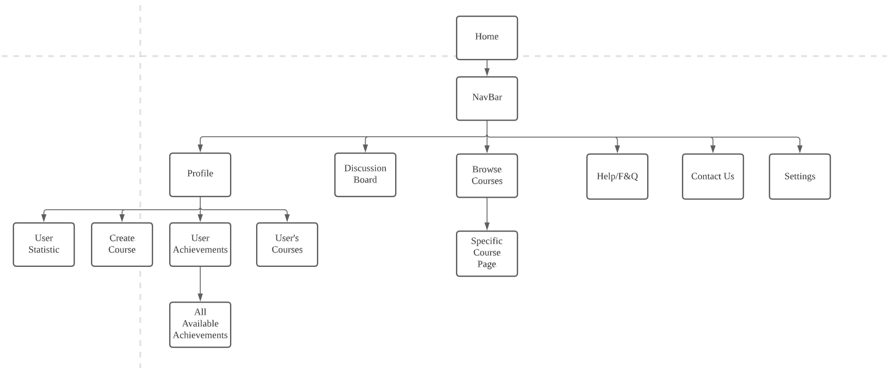

### User Flow Diagram

This is a user flow diagram for part of the application. It depicts how the user will navigate when they first enter the web application till they log in to the private pages. 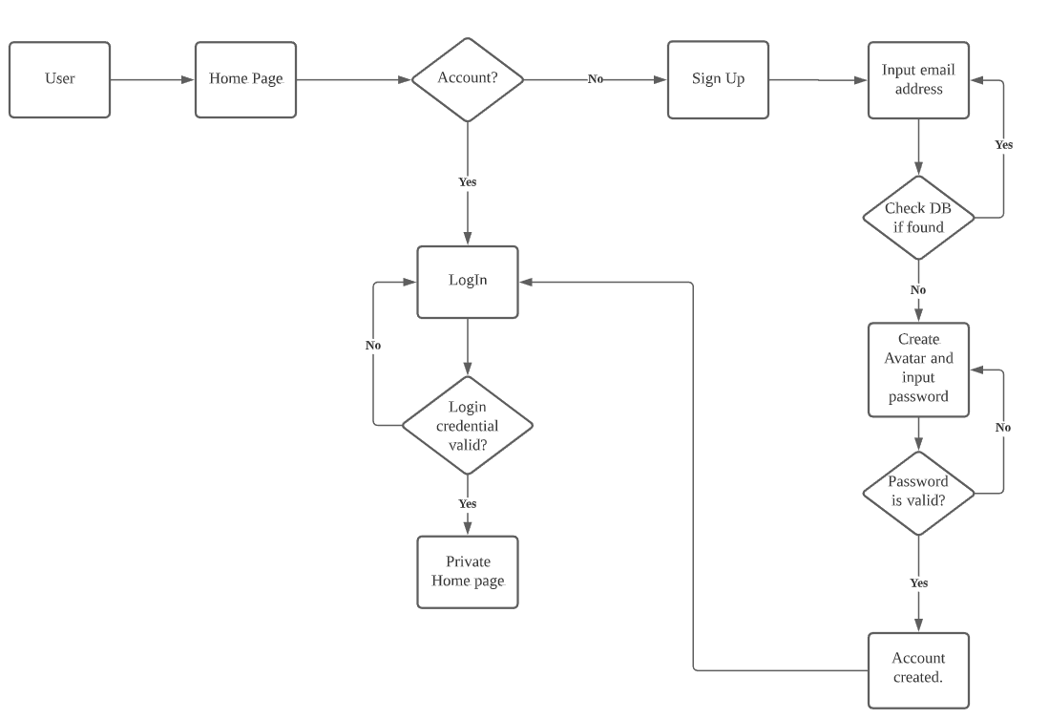

## Low-fidelity Wireframes

I worked on a simple UI design for my project. Based on the Gantt chart, I come up with some basic wireframing for the web application. Mainly on the home page and user profile page as I will be working on it. I used Figma, which is a design tool to do my wireframes. Below are 2 sample design I did using Figma.

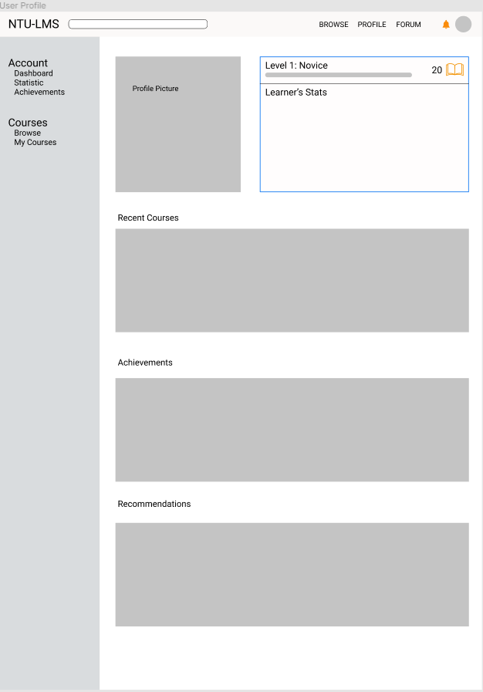 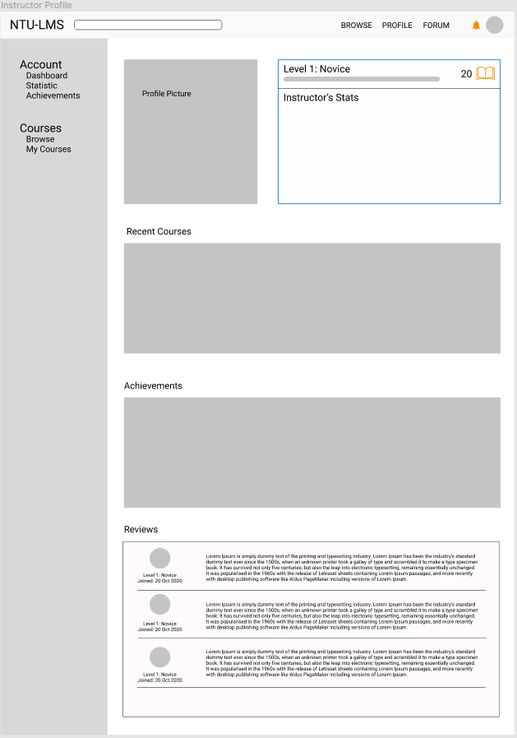

Figure 2.1.1 Learner's profile page Figure 2.1.2 Instructor's profile page

## CodeBase

### File Structure

I planned of using the following tools to create the web application.

1. Frontend framework - VueJS
2. Backend framework - ExpressJS
3. Database - MongoDB

I worked on the file structure for the codebase. I planned on doing a modular approach where I am able to reuse the file structure for other projects.

### Login/Registration

As a start to my project, a login and registration is a must. For the login, it will be using an email address and a password. I decided to use email address as it will be unique.

The signup process is split into 4 parts as seen from the image below.

1. Email validation
2. Select interested categories
3. Avatar creation
4. Confirm password

The images below are from my web application. The application is able to handle login and registration as it is linked to the database. Color scheme will be changed.

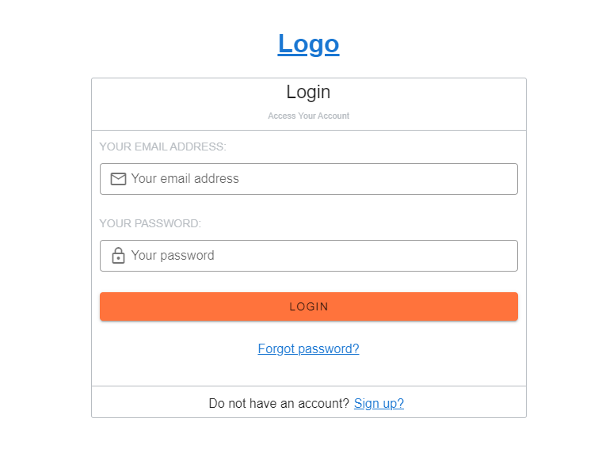

Figure 2.2.2.1 Login page

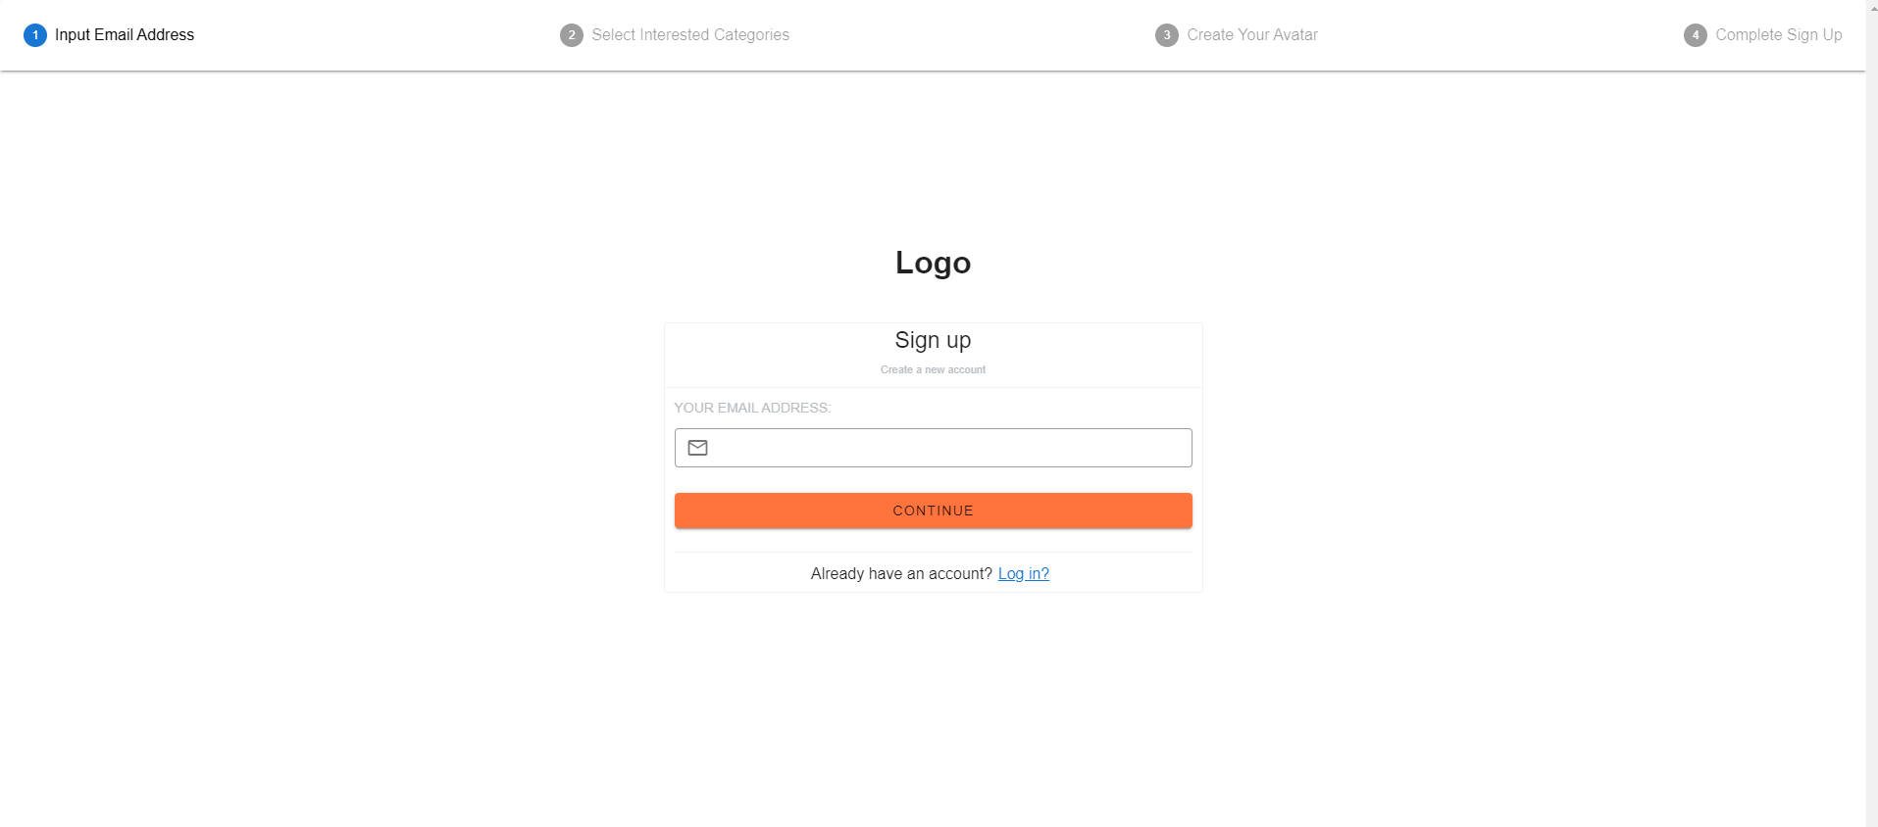

Figure 2.2.2.2 Signup process (step 1)

### Profile Page

I worked on the profile page for both the instructor and learners. As there are two different type of users on the main application, the profile page will be different. There will also be slight differences to what is being displayed.

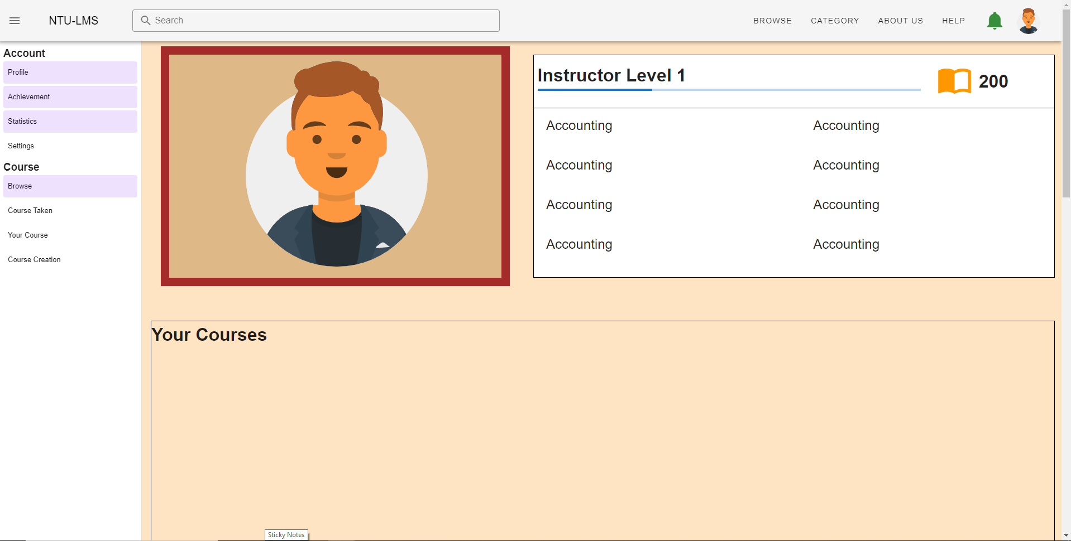

Figure 2.2.3.1 Instructor profile page

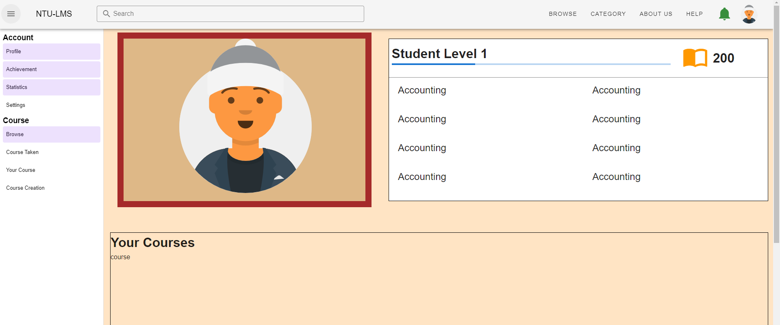

Figure 2.2.3.2 Learner’s profile page

There is also a review section on the instructor profile page, to show what learners that took his course say about the instructor. These reviews will be from a survey that learners can fill up through the web application when the course is completed. From the image below, you can see the review section with pagination. This review section is drawing data from the database.

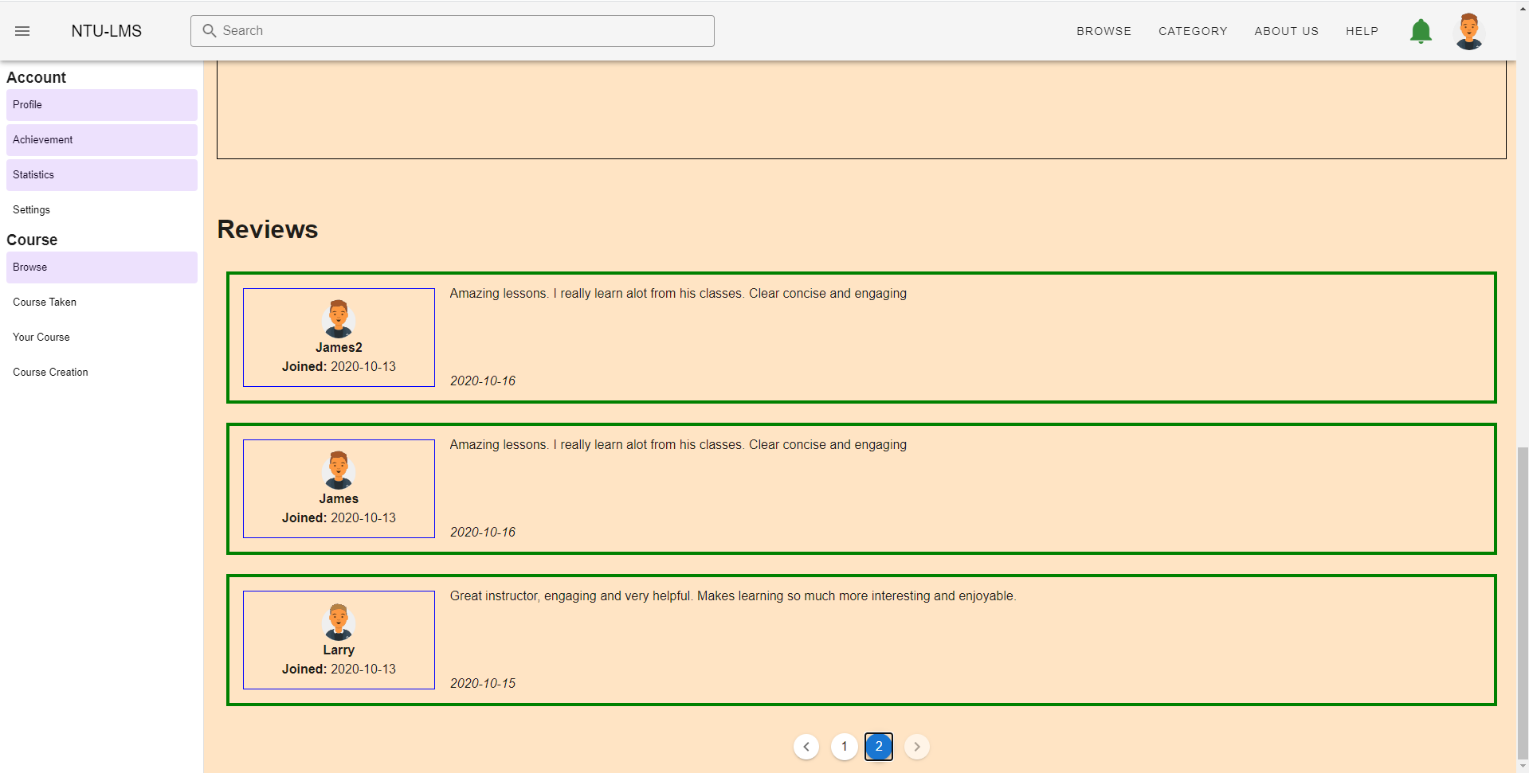

Figure 2.2.3.3 Instructor review section

### Course Creation

For my project, it will allow instructor to create their own courses and allow users to register. Details regarding the courses will be collected in through a form and save to the database. This will in turn show up in our website as an option where users can access to see the details. To do this, I will need to create a page where the instructor can fill up the required information. Below is a sample image of the website I created. You can see that the course creation is split into 3 parts:

1. Course information
2. Trainers Information
3. Fees and funding information.

Below is an image of how it currently looks like. Functionally it is working and able to create and save to the database.

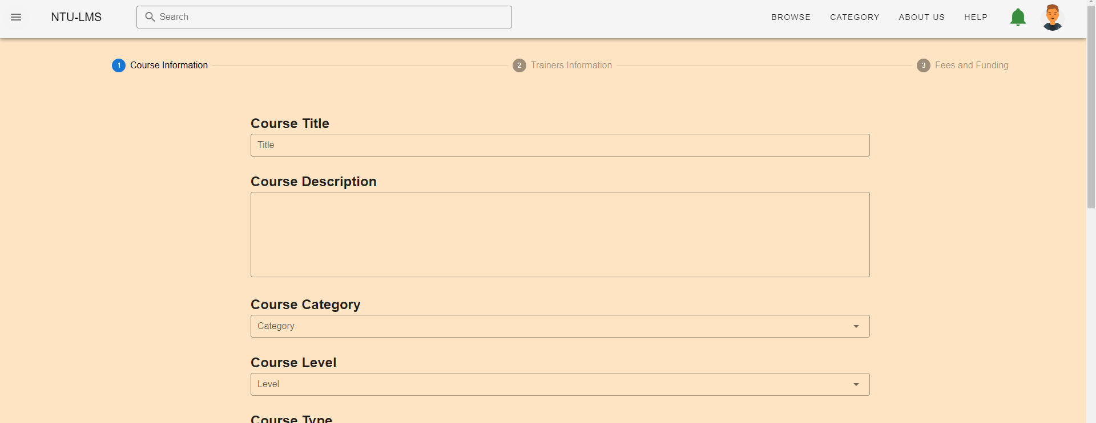

Figure 2.2.4.1 Course creation page

# Future Progress

There are still many areas that need to be worked on. Below is a list of some of the main areas that are required.

1. Learner’s discussion board
2. A specific course page
3. Statistic page for user and instructor
4. A live message feed on the home page

Some lesser areas are as follows

1. Coming up with a fixed color scheme for the web
2. Complete design for remaining pages
3. End to end testing

Understand that there are still many areas that I have yet to cover. I planned to put in more time and effort over the holiday so that I can cover more grounds than I planned base on the Gantt chart. There are also some key areas that I foresee will be challenging and hence will need to spend more time on it.

# Conclusion

In conclusion, I believe that I am currently on track to complete my FYP project. However, I would like to push for more progress in the coming winter break so as to complete it earlier than planned. I foresee there will be unexpected issue or problems that I will face as I continue working on my project and I hope to have enough time to cater to these problems.

# References

[1] <https://scand.com/company/blog/php-vs-javascript-difference-between/#:~:text=Just%20like%20Javascript%2C%20PHP%20is,and%20executed%20on%20the%20server>.

[2] <https://www.statista.com/statistics/793628/worldwide-developer-survey-most-used-languages/#:~:text=As%20of%20early%202020%2C%20JavaScript,SQL>.

[3] <https://www.comparethecloud.net/articles/understanding-the-difference-between-nosql-and-sql/>